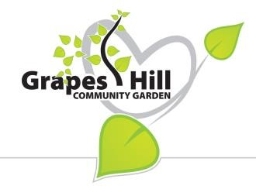
GRAPES HILL COMMUNITY GARDEN GROUP
APPLICATION FORM FOR A RAISED BED
Name
Address
Email
Tel
GHCGG membership no.
Raised Bed
Type of Application (annual fee) Small Bed Large Bed
Individual (unwaged) £5.00* £10.00*
Individual (waged) £10.00* £15.00*
Group £20.00* £25.00*
NB only the small beds have full wheelchair access.
*Plus voluntary donation to the group – please indicate amount:
Questionnaire – please answer all questions
1 Are you or your group currently a member of the GHCGG?
(All tenants of raised beds must be members of the Group)
2 Do you or the members of your group already have access to a growing space (e.g. a garden or allotment) to grow vegetables in?

3 Do you or the members of your group have any transport or mobility issues that would prevent you from taking up the offer of another growing space elsewhere in Norwich (e.g. an allotment)?

4a Do you or any of the members of your group have a disability?

4b If yes, do you require a wheelchair accessible bed?
I / We agree to abide by the rules of the GHCGG concerning tenancy of raised beds (including organic cultivation) if given the offer of one.
Signed Date

NB: Send no money now, payment is to be made by successful applicants upon signing tenancy agreement.

Prospective tenants should be aware that the garden will be open to the public and that the GHCGG will not be held responsible for any loss or damage to the contents of the raised beds.

Full rules of the tenancy agreement can be viewed on the Grapes Hill Community Garden website at www.grapeshillcommunitygarden.org or you can request a copy from GHCGG, 17 Constable Road, Norwich, NR4 6RW. A separate comprehensive list of organic gardening principles is also available.

